1. Download and Execute , MongoDB Community Server Download
2. open “C:\Program Files\MongoDB\Server\8.0\bin” and add the file to this location

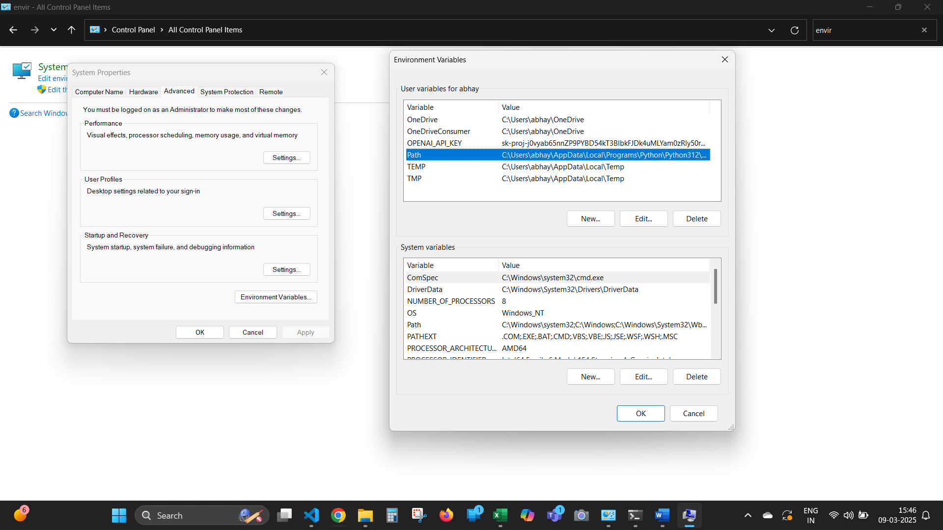

1. Add the path into path selected .
2. Open cmd and run

* mongod

1. Installing MOngoShell or mongosh- <https://www.mongodb.com/docs/mongodb-shell/>
2. Open another cmd and run withoust closing mongod

* mongosh

Resources : <https://www.geeksforgeeks.org/how-to-install-mongodb-on-windows/?ref=ml_lbp>

Use Copilot for trouble shoot